**Coding Challenge SQL**

**Virtual Art Gallery Schema DDL and DML**

-- Create the Artists table

CREATE TABLE Artists (

ArtistID INT PRIMARY KEY,

Name VARCHAR(255) NOT NULL,

Biography TEXT,

Nationality VARCHAR(100)

);

-- Create the Categories table

CREATE TABLE Categories (

CategoryID INT PRIMARY KEY,

Name VARCHAR(100) NOT NULL

);

-- Create the Artworks table

CREATE TABLE Artworks (

ArtworkID INT PRIMARY KEY,

Title VARCHAR(255) NOT NULL,

ArtistID INT,

CategoryID INT,

Year INT,

Description TEXT,

ImageURL VARCHAR(255),

FOREIGN KEY (ArtistID) REFERENCES Artists (ArtistID),

FOREIGN KEY (CategoryID) REFERENCES Categories (CategoryID)

);

-- Create the Exhibitions table

CREATE TABLE Exhibitions (

ExhibitionID INT PRIMARY KEY,

Title VARCHAR(255) NOT NULL,

StartDate DATE,

EndDate DATE,

Description TEXT

);

-- Create the ExhibitionArtworks table to connect Artworks and Exhibitions

CREATE TABLE ExhibitionArtworks (

ExhibitionID INT,

ArtworkID INT,

PRIMARY KEY (ExhibitionID, ArtworkID),

FOREIGN KEY (ExhibitionID) REFERENCES Exhibitions (ExhibitionID),

FOREIGN KEY (ArtworkID) REFERENCES Artworks (ArtworkID)

);

**DML(Insert sample data to tables)**

-- Insert sample data into the Artists table

INSERT INTO Artists (ArtistID, Name, Biography, Nationality) VALUES

(1, 'Pablo Picasso', 'Renowned Spanish painter and sculptor.', 'Spanish'),

(2, 'Vincent van Gogh', 'Dutch post-impressionist painter.', 'Dutch'),

(3, 'Leonardo da Vinci', 'Italian polymath of the Renaissance.', 'Italian');

-- Insert sample data into the Categories table

INSERT INTO Categories (CategoryID, Name) VALUES

(1, 'Painting'),

(2, 'Sculpture'),

(3, 'Photography');

-- Insert sample data into the Artworks table

INSERT INTO Artworks (ArtworkID, Title, ArtistID, CategoryID, Year, Description, ImageURL) VALUES (1, 'Starry Night', 2, 1, 1889, 'A famous painting by Vincent van Gogh.', 'starry_night.jpg'), (2, 'Mona Lisa', 3, 1, 1503, 'The iconic portrait by Leonardo da Vinci.', 'mona_lisa.jpg'),

(3, 'Guernica', 1, 1, 1937, 'Pablo Picasso\'s powerful anti-war mural.', 'guernica.jpg');

-- Insert sample data into the Exhibitions table

INSERT INTO Exhibitions (ExhibitionID, Title, StartDate, EndDate, Description) VALUES

(1, 'Modern Art Masterpieces', '2023-01-01', '2023-03-01', 'A collection of modern art masterpieces.'), (2, 'Renaissance Art', '2023-04-01', '2023-06-01', 'A showcase of Renaissance art treasures.');

-- Insert artworks into exhibitions

INSERT INTO ExhibitionArtworks (ExhibitionID, ArtworkID) VALUES

(1, 1),

(1, 2),

(1, 3),

(2, 2);

**Solve the below queries**:

1. Retrieve the names of all artists along with the number of artworks they have in the gallery, and list them in descending order of the number of artworks.  
**ANSWERS :**

SELECT a.Name, COUNT(aw.ArtworkID) AS ArtworkCount

FROM Artists a

JOIN Artworks aw ON a.ArtistID = aw.ArtistID

GROUP BY a.ArtistID, a.Name

ORDER BY ArtworkCount DESC;

**OUTPUT :**

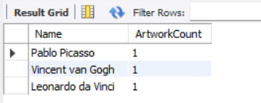

2. List the titles of artworks created by artists from 'Spanish' and 'Dutch' nationalities, and order them by the year in ascending order.

**ANSWERS :**

SELECT aw.Title, aw.Year

FROM Artworks aw

JOIN Artists a ON aw.ArtistID = a.ArtistID

WHERE a.Nationality IN ('Spanish', 'Dutch')

ORDER BY aw.Year ASC;

**OUTPUT :**

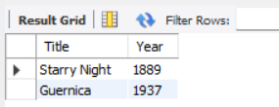

3. Find the names of all artists who have artworks in the 'Painting' category, and the number of artworks they have in this category.

**ANSWERS :**

SELECT a.Name, COUNT(aw.ArtworkID) AS PaintingCount

FROM Artists a

JOIN Artworks aw ON a.ArtistID = aw.ArtistID

JOIN Categories c ON aw.CategoryID = c.CategoryID

WHERE c.Name = 'Painting'

GROUP BY a.ArtistID, a.Name;

**OUTPUT :**

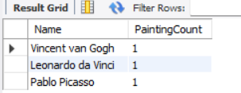

4. List the names of artworks from the 'Modern Art Masterpieces' exhibition, along with their artists and categories.

**ANSWERS :**

SELECT aw.Title AS ArtworkTitle, ar.Name AS ArtistName, c.Name AS CategoryName

FROM ExhibitionArtworks ea

JOIN Exhibitions e ON ea.ExhibitionID = e.ExhibitionID

JOIN Artworks aw ON ea.ArtworkID = aw.ArtworkID

JOIN Artists ar ON aw.ArtistID = ar.ArtistID

JOIN Categories c ON aw.CategoryID = c.CategoryID

WHERE e.Title = 'Modern Art Masterpieces';

**OUTPUT :**

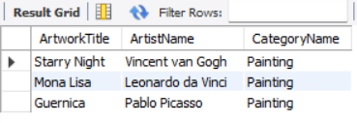

5. Find the artists who have more than two artworks in the gallery.

**ANSWERS :**

INSERT INTO Artists (ArtistID, Name, Biography, Nationality)

VALUES (4, 'Salvador Dalí', 'Spanish surrealist artist.', 'Spanish');

INSERT INTO Artworks (ArtworkID, Title, ArtistID, CategoryID, Year, Description, ImageURL)

VALUES

(13, 'The Persistence of Memory', 4, 1, 1931, 'Iconic melting clocks painting.', NULL),

(14, 'Dream Caused by the Flight of a Bee', 4, 1, 1944, 'Dreamlike surreal painting.', NULL),

(15, 'Metamorphosis of Narcissus', 4, 1, 1937, 'Surreal painting.', NULL);

SELECT a.Name, COUNT(aw.ArtworkID) AS ArtworkCount

FROM Artists a

JOIN Artworks aw ON a.ArtistID = aw.ArtistID

GROUP BY a.ArtistID, a.Name

HAVING COUNT(aw.ArtworkID) > 2;

**OUTPUT:**

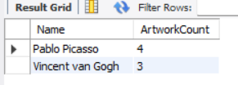

6. Find the titles of artworks that were exhibited in both 'Modern Art Masterpieces' and 'Renaissance Art' exhibitions

**ANSWERS :**

SELECT aw.Title

FROM Artworks aw

JOIN ExhibitionArtworks ea1 ON aw.ArtworkID = ea1.ArtworkID

JOIN Exhibitions e1 ON ea1.ExhibitionID = e1.ExhibitionID

JOIN ExhibitionArtworks ea2 ON aw.ArtworkID = ea2.ArtworkID

JOIN Exhibitions e2 ON ea2.ExhibitionID = e2.ExhibitionID

WHERE e1.Title = 'Modern Art Masterpieces'

AND e2.Title = 'Renaissance Art';

**OUTPUT :**



7. Find the total number of artworks in each category.

**ANSWERS :**

SELECT c.Name AS Category, COUNT(a.ArtworkID) AS TotalArtworks

FROM Categories c

JOIN Artworks a ON c.CategoryID = a.CategoryID

GROUP BY c.CategoryID, c.Name;

**OUTPUT :**

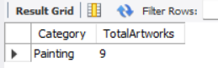

8. List artists who have more than 3 artworks in the gallery.

**ANSWERS:**

INSERT INTO Artworks (ArtworkID, Title, ArtistID, CategoryID, Year, Description, ImageURL)

VALUES

(16, 'Lobster Telephone', 4, 2, 1936, 'Surrealist sculpture.', NULL);

SELECT ar.Name, COUNT(a.ArtworkID) AS ArtworkCount

FROM Artists ar

JOIN Artworks a ON ar.ArtistID = a.ArtistID

GROUP BY ar.ArtistID, ar.Name

HAVING COUNT(a.ArtworkID) > 3;

**OUTPUT :**

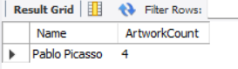

9. Find the artworks created by artists from a specific nationality (e.g., Spanish).

**ANSWERS :**

SELECT a.Title

FROM Artworks a

JOIN Artists ar ON a.ArtistID = ar.ArtistID

WHERE ar.Nationality = 'Spanish';

**OUTPUT :**



10. List exhibitions that feature artwork by both Vincent van Gogh and Leonardo da Vinci.

**ANSWERS :**

SELECT e.Title

FROM Exhibitions e

JOIN ExhibitionArtworks ea ON e.ExhibitionID = ea.ExhibitionID

JOIN Artworks a ON ea.ArtworkID = a.ArtworkID

JOIN Artists ar ON a.ArtistID = ar.ArtistID

WHERE ar.Name IN ('Vincent van Gogh', 'Leonardo da Vinci')

GROUP BY e.ExhibitionID, e.Title

HAVING COUNT(DISTINCT ar.ArtistID) = 2;

**OUTPUT :**

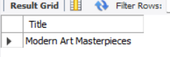

11. Find all the artworks that have not been included in any exhibition.

**ANSWERS :**

SELECT a.Title

FROM Artworks a

LEFT JOIN ExhibitionArtworks ea ON a.ArtworkID = ea.ArtworkID

WHERE ea.ExhibitionID IS NULL;

**OUTPUT :**

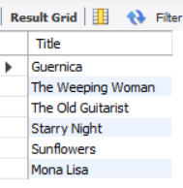

12. List artists who have created artworks in all available categories.

**ANSWERS :**

INSERT INTO Artworks (ArtworkID, Title, ArtistID, CategoryID, Year, Description, ImageURL)

VALUES

(17, 'Picasso Painting', 1, 1, 1937, 'Painting by Picasso', NULL),

(18, 'Picasso Sculpture', 1, 2, 1939, 'Sculpture by Picasso', NULL),

(19, 'Picasso Photo', 1, 3, 1940, 'Photography by Picasso', NULL);

SELECT ar.Name

FROM Artists ar

JOIN Artworks a ON ar.ArtistID = a.ArtistID

GROUP BY ar.ArtistID, ar.Name

HAVING COUNT(DISTINCT a.CategoryID) = (SELECT COUNT(*) FROM Categories);

**OUTPUT :**

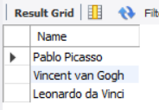

13. List the total number of artworks in each category.

**ANSWERS :**

SELECT c.Name AS Category, COUNT(a.ArtworkID) AS TotalArtworks

FROM Categories c

LEFT JOIN Artworks a ON c.CategoryID = a.CategoryID

GROUP BY c.CategoryID, c.Name;

**OUTPUT :**

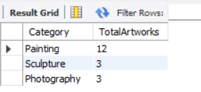

14. Find the artists who have more than 2 artworks in the gallery.

**ANSWERS :**

SELECT ar.Name, COUNT(a.ArtworkID) AS ArtworkCount

FROM Artists ar

JOIN Artworks a ON ar.ArtistID = a.ArtistID

GROUP BY ar.ArtistID, ar.Name

HAVING COUNT(a.ArtworkID) > 2;

**OUTPUT :** 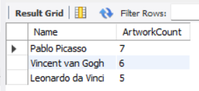

15. List the categories with the average year of artworks they contain, only for categories with more than 1 artwork.

**ANSWERS :**

SELECT c.Name, AVG(a.Year) AS AverageYear

FROM Categories c

JOIN Artworks a ON c.CategoryID = a.CategoryID

GROUP BY c.CategoryID, c.Name

HAVING COUNT(a.ArtworkID) > 1;

**OUTPUT**:

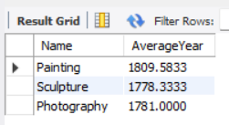

16. Find the artworks that were exhibited in the 'Modern Art Masterpieces' exhibition.

**ANSWERS :**

SELECT a.Title

FROM Artworks a

JOIN ExhibitionArtworks ea ON a.ArtworkID = ea.ArtworkID

JOIN Exhibitions e ON ea.ExhibitionID = e.ExhibitionID

WHERE e.Title = 'Modern Art Masterpieces';

**OUTPUT :**

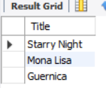

17. Find the categories where the average year of artworks is greater than the average year of all artworks.

**ANSWERS :**

SELECT c.Name, AVG(a.Year) AS CategoryAvgYear

FROM Categories c

JOIN Artworks a ON c.CategoryID = a.CategoryID

GROUP BY c.CategoryID, c.Name

HAVING AVG(a.Year) > (SELECT AVG(Year) FROM Artworks);

**OUTPUT :**

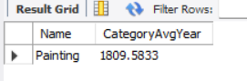

18. List the artworks that were not exhibited in any exhibition.

**ANSWERS :**

SELECT a.Title

FROM Artworks a

LEFT JOIN ExhibitionArtworks ea ON a.ArtworkID = ea.ArtworkID

WHERE ea.ExhibitionID IS NULL;

**OUTPUT :**

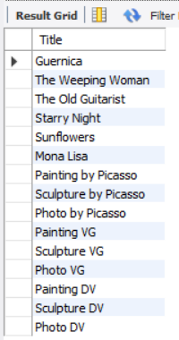

19. Show artists who have artworks in the same category as "Mona Lisa."

**ANSWERS :**

SELECT DISTINCT ar.Name

FROM Artists ar

JOIN Artworks a ON ar.ArtistID = a.ArtistID

WHERE a.CategoryID = (

SELECT CategoryID FROM Artworks WHERE Title = 'Mona Lisa' LIMIT 1

);

**OUTPUT :**

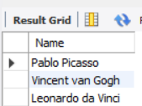

20. List the names of artists and the number of artworks they have in the gallery.

**ANSWERS :**

SELECT ar.Name, COUNT(a.ArtworkID) AS ArtworkCount

FROM Artists ar

JOIN Artworks a ON ar.ArtistID = a.ArtistID

GROUP BY ar.ArtistID, ar.Name;

**OUTPUT :**

